**The Third Annual Sanctuary Keyboards Festival**

Sundays at 3:00 p.m.

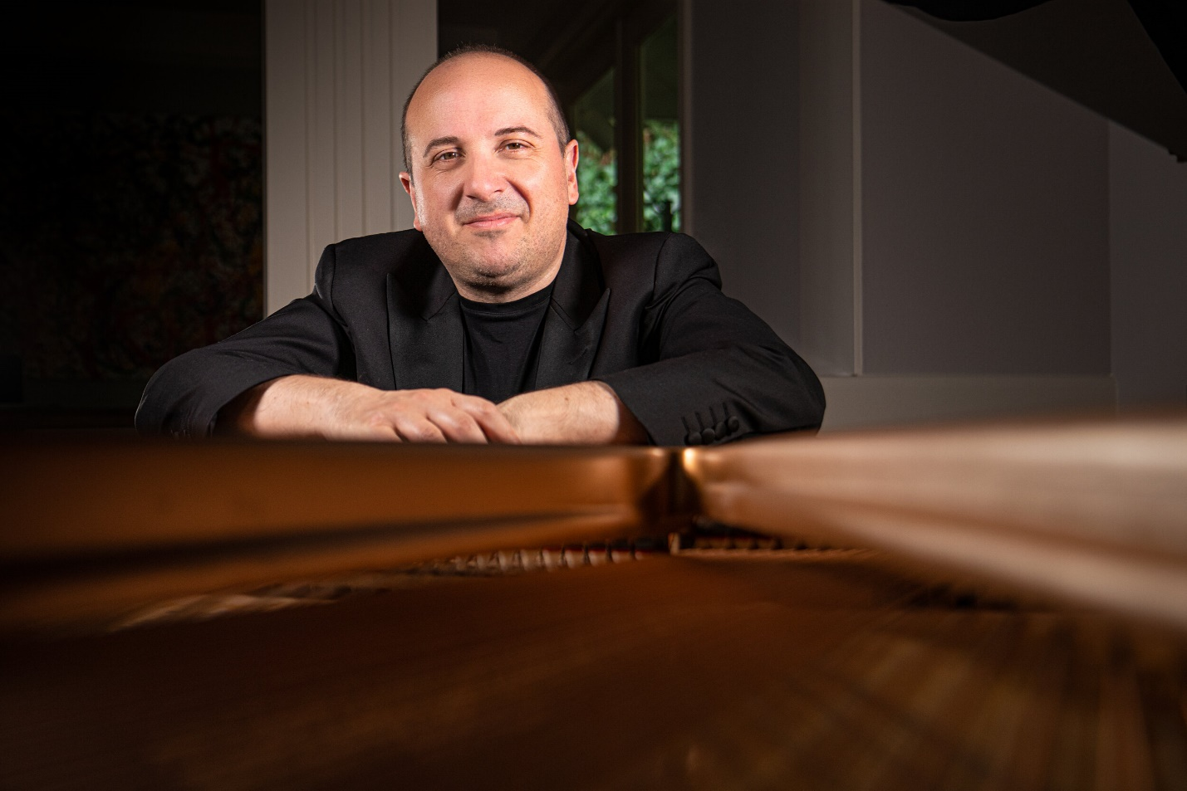

October 12: Lorenzo Marasso, Pianist

Founder and Music Director, Seattle Chamber Orchestra

*From Light to Passion:*

*Haydn, Mozart, Chopin, Franck & Liszt at the Piano*

**Plan to attend, and bring your friends!**

**Free & open to all.**